Motor Skills
Name
Institution
Motor Skills
Motor skills are described as the ability of muscles to move as they cause an action. There is always a maximum certainty to the happening of a predetermined movement which results to the movement outcome. Motor learning is, therefore, the permanent change which occurs to enable a person to gain the skill of performing specific movement ability as a result of experience or practice. Performance, however, is associated with the act of portraying motor skills and therefore their goal is to ensure that one can maintain the rate of success as they grow and enhance their ability to reduce the energy consumed during the performance (Jeffery, 2018). Hence, when an individual indulges in consistent practice or exposure to experience, they gain the ability to improve the performance of their motor skills.

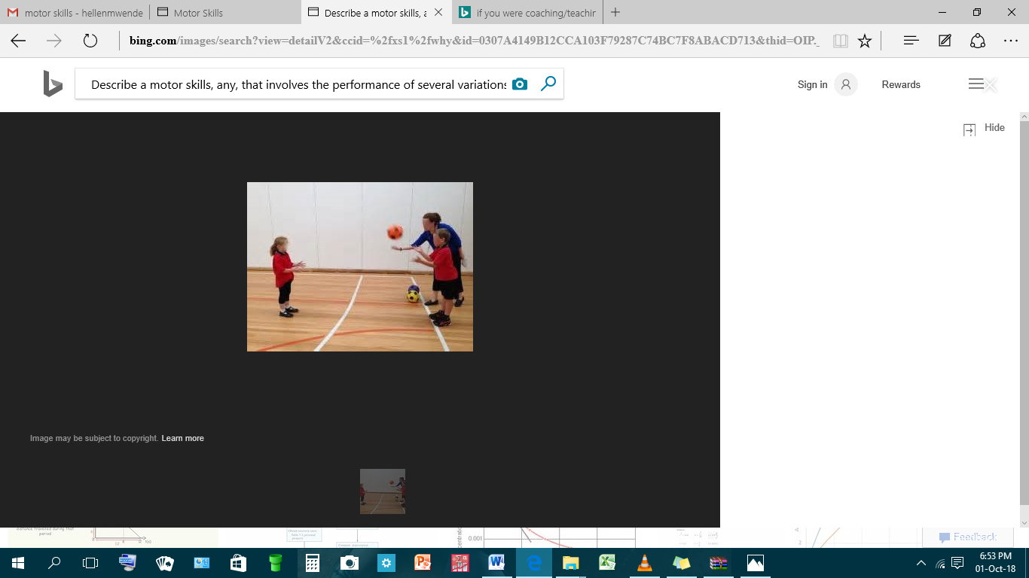
The acquisition of motor skills has been defined for a very long time as the energy-intensive type of stimulus-response which leads to robust neuronal modifications. Thorndike in 1898 developed a law of effect whereby he proposed that any affiliation between an action and the environmental conditions gets improved whenever the action is followed by an outcome which is satisfying. For example, if a baby has the ability to move the right arm and left leg correctly, then they bare the capability of producing an outcome that satisfies them and as a result increases their mobility (Stallings, 2018). The arm is, therefore, able to move freely even though the four limbs are involved. Accordingly, any motion that is dissatisfying results from the contraction of the muscles of a child which causes pain and disables the child from associating the arm and the leg in the same environmental condition.

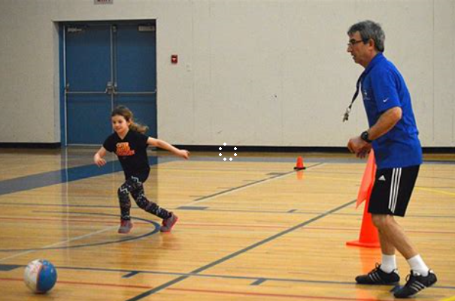
The gross motor skills involve the performance of several variations of muscles which allow one to make use of the large muscles only to walk, crawl or balance. These skills are mostly associated with continuous tasks which entail continued muscle movement. For a person to fully develop these motor skills, their childhood needs to be active so that they can produce them consistently. However, the performance of these kinds of motor skills does not change even with the continued time of non-use. This is because the muscles get used to the type of movements that allows performance and the brain registers such information to be referred to in the future (Jeffery, 2018). Furthermore, gross motor skills are categorized into two groups which include locomotors skills and object-control skills. The locomotors skills involve jumping, running and swimming while the object control skills involve kinking, throwing and catching.

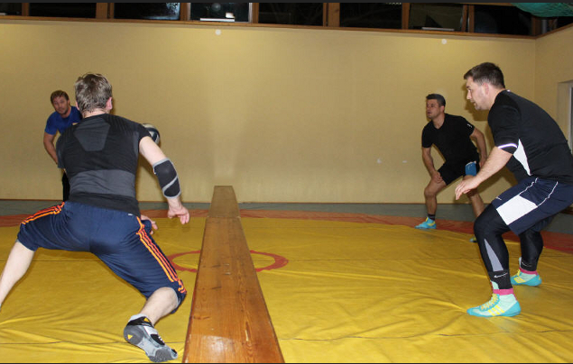
To coach a student-athlete the performance of the variations of the locomotors skills, they would require to be distributed evenly in six months so that better results can be achieved. Also, six months would provide enough time for practice and experience which would improve the performance of running as a motor skill. Therefore for starters, the coach would be required to understand the level at which the student-athlete has reached or instead how far their skills have developed over time so that they can design the perfect exercise to improve these muscles and provide better muscle performance (Stallings, 2018). For instance, the coach would ensure to develop these muscles from the gross to specific growth. This entails training the muscles to become more specific in their performance so that as the student-athlete runs, they can quickly learn how to coordinate the leg muscles and the arm muscles as they move through the wind.
Through the process of learning, a student-athlete can be taught how to use the available environmental factors to alter or change the appearance of several developmental features. This will entail training them more on how to deal with muscle stress in the shortest time possible for better performance. Hence, a coach should distribute all these learning factors throughout the six months so that the student-athlete can finally acquire perfect training of the muscles for better performance (Jeffery, 2018). The stages of motor learning, in this case, will need to be applied fully for better results.
The first stage is known as the cognitive phase which can take about two weeks to complete training. During the two weeks, the coach will ensure to design what needs to be done and guide the student-athlete through every step. In this case, a considerable cognitive activity will be applied for the student-athlete to learn all the appropriate strategies which are supposed to reflect on the desired and targeted goal and objective (Stallings, 2018). The second stage will take a month and two weeks and it is known as the associative phase. Here the student-athlete will start implementing all several steps so that performance can be improved. The movements here are consistent and require more attention.
Lastly, the coach will take the remaining four months to make the student-athlete through the autonomous phase which ensures that a learner is capable of completing all tasks automatically without having to concentrate. This is because they have the fundamental knowledge obtained from the first two stages (Jeffery, 2018). Hence at this point, the student learner will showcase their skills as they practice the motor skills every day for the better performance of the muscles.

References
Jeffery, J. H. (2018). “Understanding Motor Learning Stages improves Skill Instruction.” Human Kinetics.
Stallings, L. M. (2018). “Motor Skills: Development and Learning.” Boston: WCB/McGraw-Hill.

